Name:………………………………………………..…. Date:………………………………………………………
Crystal chemistry
Snow crystals
Snow is made from crystals of water. With some careful preparations, snow can be grown in a laboratory. Look at the demonstration, label the apparatus diagram and answer the questions.
Growing snow crystals
Don't expect an avalanche – but it's true, snow can be grown!
What you do
Label the diagram of the apparatus used to make snow crystals with the following labels: sponge - pins - thread - paper clip - bottle - dry ice - container - cover - crystals.
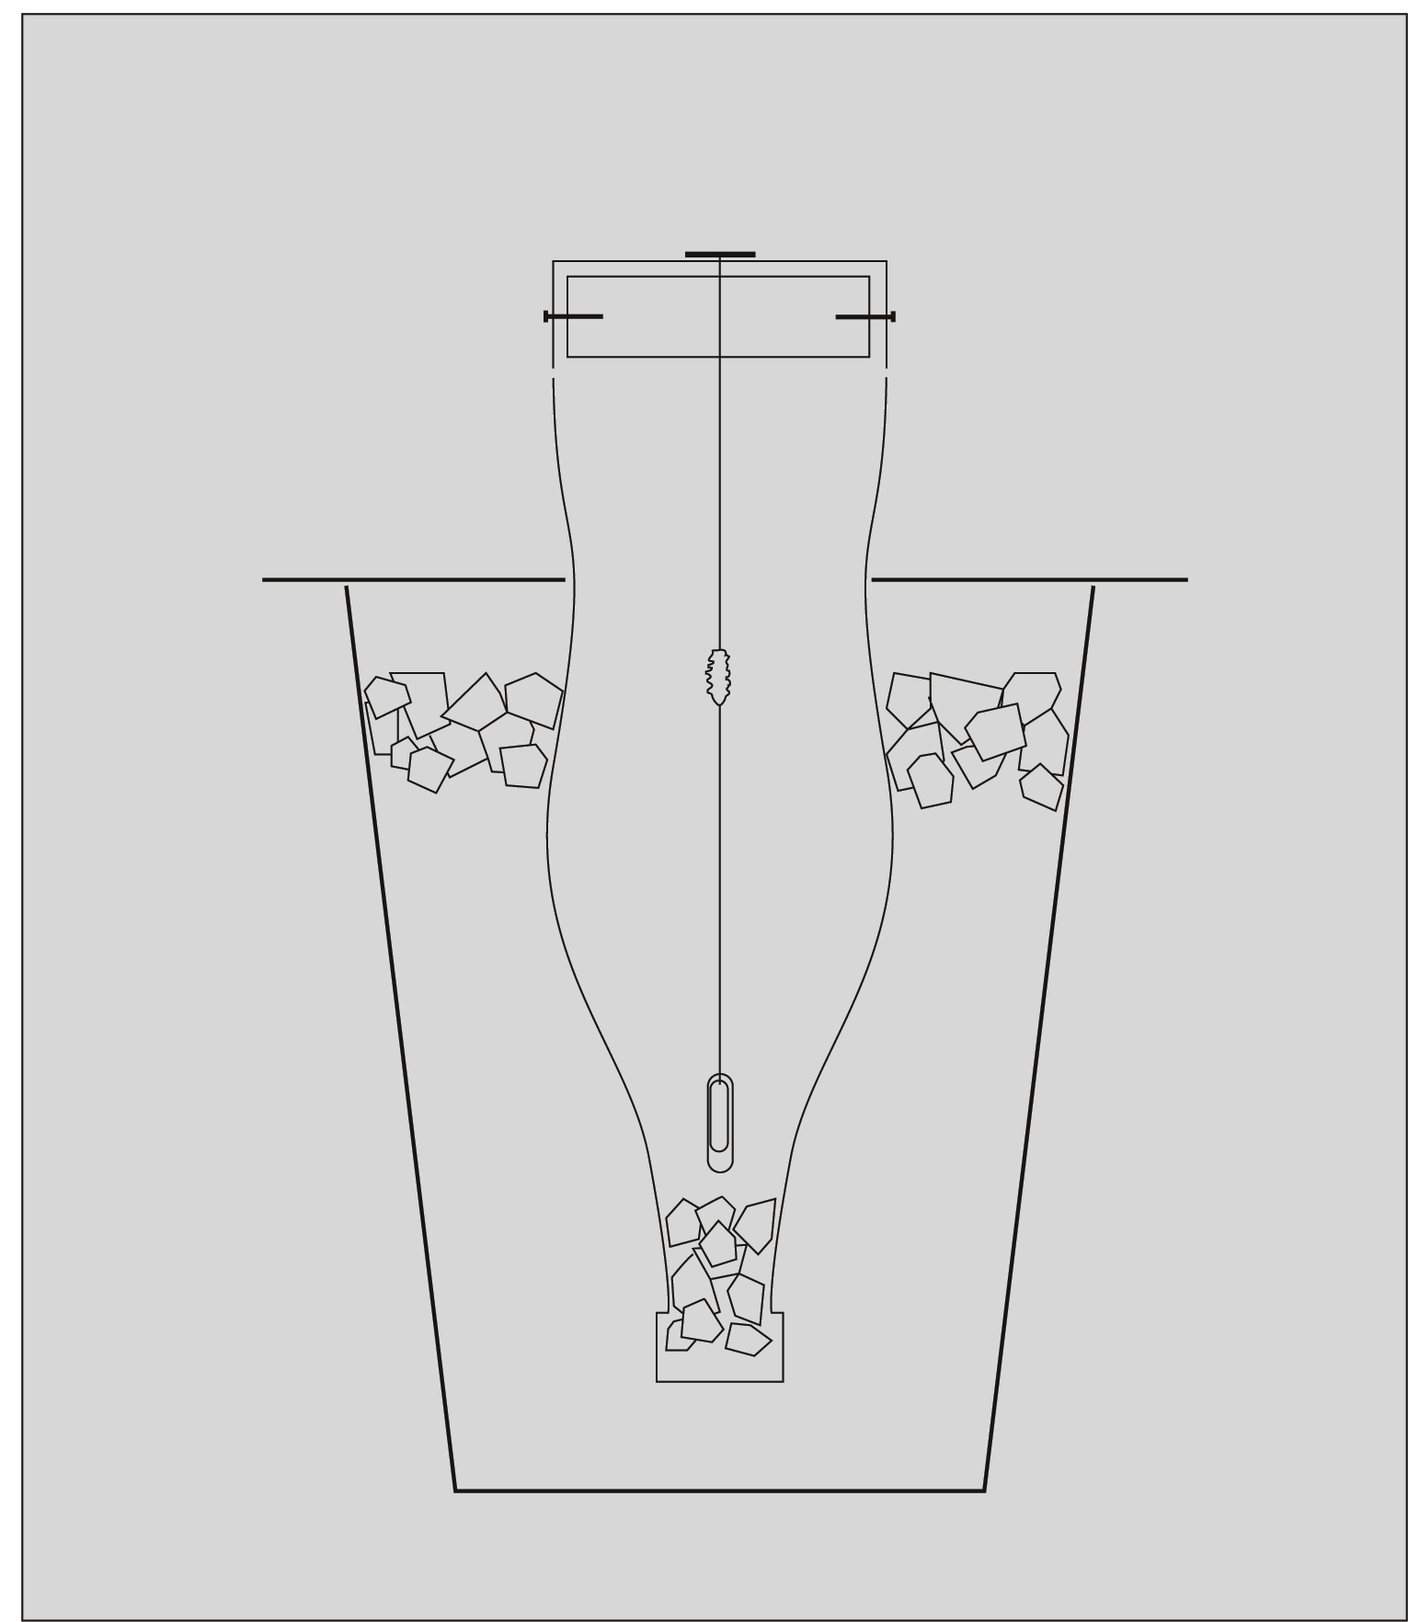

continued on next page


Crystal chemistry
continued from previous page
Questions
1. How big were the snow crystals? ……………………………………………………………………………………………………………….……………………………………………………………………………………………………………….……………………………………………………………………………………………………………….……………………………………………………………………………………………………………….
2. What happened when they were lifted out of the bottle? ……………………………………………………………………………………………………………….……………………………………………………………………………………………………………….……………………………………………………………………………………………………………….……………………………………………………………………………………………………………….
3. What conditions are needed for good snow to form? How is this like growing other types of crystals? ……………………………………………………………………………………………………………….……………………………………………………………………………………………………………….……………………………………………………………………………………………………………….……………………………………………………………………………………………………………….……………………………………………………………………………………………………………….……………………………………………………………………………………………………………….……………………………………………………………………………………………………………….……………………………………………………………………………………………………………….

